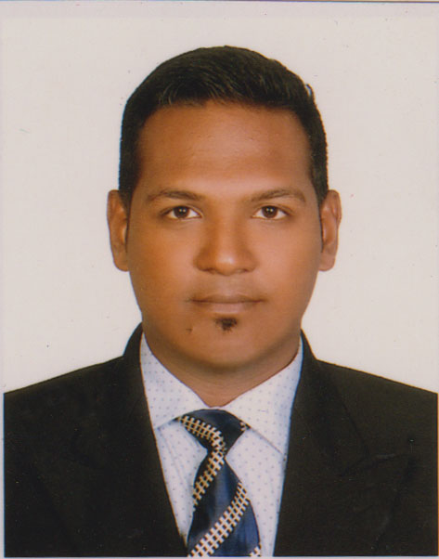**Md. Ashiqur Rahman**

Cell: 01717861089

Email: [anikbsceee@gmail.com](mailto:anikbsceee@gmail.com)

***Career Objectives :***

Always possess a passion to work in esteemed organization replete with teamwork, vigor and excellent growth opportunities. Cherish to gain expertise through challenges, developing new ideas & concepts and meeting deadlines at the same time. Aim to move forward through creating values and thinking beyond imagination.

***Employment History:***

1: Junior Executive Engineer ( January 1,2017- 31 Dec, 2018 )  
MONICO TECHNOLOGY LIMITED  
Department :IT  
Location : Shymoli 26 & 27 Ring road Dhaka. ***Education :***

* Daffodil International University, Dhaka, Bangladesh.

B.Sc.(Eng) in Electrical and Electronics Engineering

CGPA 2.63 (Out of 4.00) 2nd class , Exam Held 2016

* Kushtia Government College, Kushtia.

HSC in Science Group

GPA 3.60 (out of 5.00), Exam Held 2011

* Kushtia Zilla School, Kushtia

SSC in Science Group

GPA 4.75 (out of 5.00), Exam Held 2009

***Training & Workshops :***

Successfully completed the training on   
“Basic Electrical and Instrumentation” from TICI at Aug 2016.

***Computer Skills :***

**General**: Skilled in Microsoft office package (Word, Excel, PowerPoint, and Outlook), basic hardware maintenance & troubleshooting.

**Operating System:** Windows XP/Vista/7, to some extent -UBUNTU.

**Other software package:** Microsoft Visio, Microsoft office Publisher (for creating & editing newsletter, Brochures, flyers and web sites) basic skills.

**Others:** Blogging, English word typing speed - around 35 WPM.

***Languages:***

* Highly proficient in Bangla. And this native language.
* Highly proficient in English

***Interests and Activities:***

I am an active participant in several social groups; I am active in organizing Study Tour and various Cultural activities.

***Hobbies:***

I read loads of books. Ranging from thrillers to Novels, I am fond of any books that are intriguing regardless of the type a (a page-turner or a comic). I love to play Cricket, watch movies and hang out with friends. I enjoy gardening in my balcony and rooftop. I like to spend holydays traveling. I am internet-savvy.

***Personal Information:***

Name : Md. Ashiqur Rahman (Anik)

Fathers Name :Md Abdur Razzak

Mothers Name : Afroza Parveen

Date of Birth : 11 August 1994

Marital Status : Single

National ID No : 1019926128

Permanent Address: H#246, Jhenaidah Sarak, Apexlane,

Custom More, Chourhash, Kushtia.

***References:***

Mahmudur Rahman

Chemist

BPC Central Laboratory

Chevron Bangladesh

Bibiyana Gas Plant

Karimpur, Nabiganj, Hobigonj  
Shylet

Email : manna.acct@gmail.com  
Cell: 01717385152

Md Roushon Ali

Vice President

Southeast Bank Limited

Kaoranbazar Branch

Dhaka.

Cell: 01712679612

Email: roushon.pb@gmail.com

***Declaration:***

I, hereby, declare that all the details mentioned above are my own and true to the best of my knowledge.

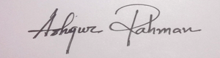

**Date:**

**(Md. Ashiqur Rahman)**